

**Product Dissection for Snapchat**

**Company Overview:**

**Snapchat, founded in 2011 by Evan Spiegel, Bobby Murphy, and Reggie Brown, has redefined the way people communicate and share moments through ephemeral messaging and multimedia content. With its unique approach to self-destructing messages and creative features like lenses and filters, Snapchat has captured the attention of millions of users worldwide. Acclaimed for its innovative design and user-centric features, Snapchat has emerged as a prominent player in the social media industry.**

**Product Dissection and Real-World Problems Solved by Snapchat:**

**Snapchat, a pioneering social media platform, has effectively addressed real-world challenges through its innovative product offerings. With a focus on ephemeral messaging and creative expression, Snapchat empowers users to share moments authentically and connect with others in a dynamic and engaging manner.**

**Snapchat's core feature of ephemeral messaging solves the problem of privacy and self-expression in digital communication. By allowing users to send photos and videos that disappear after viewing, Snapchat provides a sense of privacy and spontaneity, encouraging users to share moments without the fear of permanence or judgment. This feature bridges the gap between digital interactions and real-life experiences, fostering genuine connections and meaningful conversations among users.**

**Additionally, Snapchat's creative tools and features, such as lenses, filters, and stickers, enhance user engagement and expression. These innovative tools enable users to transform their photos and videos into playful and visually captivating content, adding a layer of fun and personality to their communication. By addressing the challenge of monotony and limited expression in digital communication, Snapchat stimulates creativity and self-expression, making interactions more dynamic and engaging.**

**Snapchat's Discover feature revolutionizes content discovery by curating personalized content from media partners and creators. By providing a curated feed of news, entertainment, and trending topics, Discover offers users a seamless way to stay informed and entertained within the Snapchat app. This**

**Feature solves the problem of information overload and content fragmentation, offering users a centralized platform for discovering and consuming content aligned with their interests.**

**In conclusion, Snapchat's product design has successfully tackled real-world problems by offering innovative solutions that prioritize privacy, creativity, and engagement. Through its unique features and user-centric approach, Snapchat has reshaped the digital landscape, providing users with a platform for authentic expression, meaningful connections, and immersive experiences.**

**This case study showcases how Snapchat's product offerings have addressed real-world challenges, making it a leading player in the social media industry and shaping the way people communicate and share moments online.**

**Case Study: Real-World Problems and Snapchat's Innovative Solutions**

**Snapchat, a leading social media platform, has tackled various real-world challenges through its innovative features and user-centric approach. By addressing these challenges, Snapchat has created a safer, more inclusive, and enjoyable digital environment for its users.**

**Problem 1: Privacy Concerns and Data Security**

**Real-World Challenge: Users are increasingly concerned about the privacy and security of their personal information on social media platforms, given the prevalence of data breaches and privacy infringements.**

**Snapchat's Solution:**

**Snapchat prioritizes user privacy and data security by implementing features like end-to-end encryption for messages and stringent privacy settings. The platform regularly updates its security protocols to protect user data from potential threats, ensuring a safe and secure user experience.**

**Problem 2: Cyber bullying and Online Harassment**

**Real-World Challenge: Cyber bullying and online harassment remain pervasive issues, leading to psychological distress and negative mental health outcomes for affected individuals, especially among younger demographics.**

**Snapchat's Solution:**

**To combat cyber bullying and online harassment, Snapchat provides users with robust reporting and blocking mechanisms. The platform also promotes digital civility campaigns and offers resources for users to seek support and assistance when facing harassment, fostering a safer and more supportive online environment.**

**Problem 3: Societal Pressure and Self-Obsession**

**Real-World Challenge: Social media platforms contribute to societal pressure and self-obsession, with users feeling the need to present curate versions of their lives and constantly seek validation through likes and comments.**

**Snapchat's Solution:**

**Snapchat counters societal pressure and self-obsession by promoting authenticity and ephemeral content. The platform's ephemeral messaging feature encourages users to share unfiltered moments without the pressure of permanent documentation, fostering genuine interactions and reducing the focus on likes and follower counts.**

**Problem 4: Nudity Culture and Inappropriate Content**

**Real-World Challenge: Users may encounter inappropriate content, including nudity and explicit imagery, on social media platforms, leading to discomfort and concerns about exposure to harmful content, especially among younger users.**

**Snapchat's Solution:**

**Snapchat employs strict content moderation policies and utilizes advanced technology to detect and remove inappropriate content swiftly. Additionally, the platform provides users with tools to control their content exposure and report violations, ensuring a safer and more age-appropriate experience for all users.**

**Problem 5: Digital Literacy and Online Safety**

**Real-World Challenge: Many users lack the necessary digital literacy skills to navigate online platforms safely, increasing their vulnerability to online threats such as phishing scams and identity theft.**

**Snapchat's Solution:**

**Snapchat promotes digital literacy and online safety through educational resources and tutorials on topics such as privacy settings, cyber security, and recognizing online threats. The platform collaborates with educational institutions and organizations to raise awareness about online safety, empowering users to make informed decisions and protect themselves online.**

**Problem 6: Diversity and Inclusion in Online Spaces**

**Real-World Challenge: Online platforms often struggle with fostering diversity and inclusion, leading to marginalized communities feeling excluded or misrepresented.**

**Snapchat's Solution:**

**Snapchat promotes diversity and inclusion through initiatives that amplify underrepresented voices and stories. The platform features diverse content creators and partners with organizations that advocate for marginalized communities, creating a more welcoming and representative online environment for users from all backgrounds.**

**Conclusion:**

**Snapchat's commitment to addressing real-world challenges demonstrates its dedication to providing a positive and empowering social media experience for users. By prioritizing privacy, safety, authenticity, and diversity, Snapchat continues to innovate and evolve as a platform that reflects the diverse needs and experiences of its global user base.**

**Top Features of Snapchat:**

**Stories: Snapchat's Stories feature allows users to share photos and videos that disappear after 24 hours. This ephemeral content encourages spontaneous sharing and keeps users engaged with fresh updates.**

**Lenses and Filters: Snapchat offers a wide range of augmented reality (AR) lenses and filters that users can apply to their snaps. These playful features enable users to add fun effects, animations, and facial distortions to their photos and videos.**

**Discover: The Discover feature on Snapchat provides a curated selection of content from publishers, creators, and influencers. Users can explore news articles, original shows, and editorial content from various media outlets and entertainment brands.**

**Snap Map: Snap Map allows users to share their location with friends in real-time and view Snaps from nearby locations. This feature enhances social connections by enabling users to see what's happening around them and plan meet ups with friends.**

**Chat and Messaging: Snapchat offers a range of messaging features, including text chats, voice and video calls, and multimedia messaging. The platform also supports group chats and allows users to send disappearing messages.**

**Memories: Snapchat's Memories feature enables users to save and revisit their favorite Snaps and Stories. Users can create photo albums, edit saved Snaps, and share memories with friends or post them to their Story.**

**Bitmoji Integration: Snapchat integrates Bitmoji, personalized avatar stickers, into its platform, allowing users to express themselves in chat conversations and on snaps. Bitmoji adds a playful and customizable element to user interactions.**

**Snap Originals: Snap Originals are original, short-form shows produced exclusively for Snapchat. These bite-sized series cover a range of genres, including comedy, drama, and documentaries, providing users with entertaining and engaging content directly within the app.**

**Schema Description for Snapchat:**

**The schema for Snapchat involves multiple entities representing various aspects of the platform, facilitating interactions among users and content sharing. These entities include Users, Snaps, Chats, Stories, Friends, Filters, and more. Each entity has specific attributes defining its properties and relationships with other entities.**

**User Entity:**

**Users form the foundation of Snapchat. The user entity contains information about each user:**

* **UserID (Primary Key): A unique identifier for each user.**
* **Username: The chosen username for the user's account.**
* **Email: The user's email address for account-related communication.**
* **Full_Name: The user's full name as displayed on their profile.**
* **Bitmoji: A personalized avatar representing the user.**
* **Registration_Date: The date when the user joined Snapchat.**

**Snap Entity:**

**Snaps capture the visual content shared on the platform:**

* **SnapID (Primary Key): A unique identifier for each snap.**
* **UserID (Foreign Key referencing User Entity): The user who created the snap.**
* **Media_Type: Indicates whether the snap is an image, video, or other multimedia content.**
* **Snap_Content: The URL or binary data of the snap content.**
* **Snap_Date: The date and time when the snap was created.**
* **FilterID (Foreign Key referencing Filter Entity): The filter applied to the snap, if any.**

**Story Entity:**

**Stories allow users to share a series of snaps that disappear after 24 hours:**

* **StoryID (Primary Key): A unique identifier for each story.**
* **UserID (Foreign Key referencing User Entity): The user who created the story.**
* **Story_Content: The content of the story, comprising multiple snaps.**
* **Story_Date: The date and time when the story was created.**

**Comment Entity:**

**Comments enable users to engage in conversations around snaps:**

* **CommentID (Primary Key): A unique identifier for each comment.**
* **SnapID (Foreign Key referencing Snap Entity): The snap being commented on.**
* **UserID (Foreign Key referencing User Entity): The user who posted the comment.**
* **Text: The text of the comment.**
* **Comment_Date: The date and time when the comment was posted.**

**Inbox Entity:**

**The Inbox entity manages direct messages and communication between users:**

* **InboxID (Primary Key): A unique identifier for each inbox.**
* **UserID (Foreign Key referencing User Entity): The user who owns the inbox.**
* **Unread_Count: The number of unread messages in the inbox.**
* **Last_Message: The content of the last message received in the inbox.**
* **Last_Message_Date: The date and time of the last message received.**

**Friend Entity:**

**Friends represent connections between users:**

* **FriendshipID (Primary Key): A unique identifier for each friendship.**
* **UserID (Foreign Key referencing User Entity): The user who initiated the friendship.**
* **FriendID (Foreign Key referencing User Entity): The user who is the friend.**
* **Friendship_Date: The date when the friendship was established.**

**Filter Entity:**

**Filters provide users with creative enhancements for their snaps:**

* **FilterID (Primary Key): A unique identifier for each filter.**
* **Filter_Name: The name or description of the filter.**
* **Filter_Type: Indicates whether the filter is an image overlay, animation, or other effects.**
* **Filter_Content: The URL or binary data of the filter content.**
* **UserID (Foreign Key referencing User Entity): The user who created or owns the filter.**

**Relationships are:**

**Users send Snaps:**

* **Each user can send many snaps to their friends or post them as stories.**
* **Each snap is created and sent by only one user.**

**Users contribute to Stories:**

* **Users can create stories by sharing multiple snaps that form a series.**
* **Each user can create multiple stories over time.**
* **Each story can contain multiple snaps contributed by the same user.**

**Users connect as Friends:**

* **Users can connect with each other by becoming friends on Snapchat.**
* **Each user can have multiple friends.**
* **A friendship involves two users: one initiates the friendship, and the other becomes the friend.**

**Snaps may use Filters:**

* **When users send snaps, they can apply various filters to enhance their content.**
* **Each snap can be associated with one filter that modifies its appearance.**
* **Each filter can be used on multiple snaps sent by different users.**

**ER Diagram:**

**This ER diagram provides a succinct overview of the core entities and their relationships within the Snapchat schema. It highlights the interconnectedness of various components, facilitating a better understanding of Snapchat's data model and interactions between users and content on the platform.**

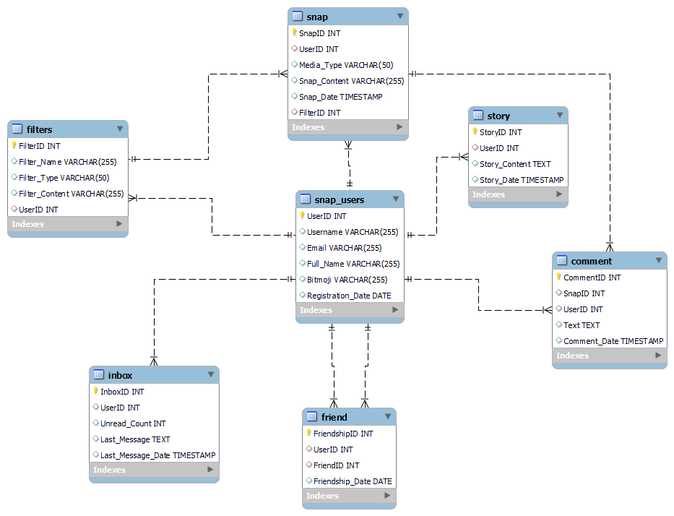

**Conclusion: In conclusion, Snapchat's innovative product design has effectively addressed real-world challenges by prioritizing privacy, safety, authenticity, and creativity. Through features like ephemeral messaging, lenses, filters, and Discover, Snapchat empowers users to share authentic moments, express creativity, and discover curate content within a safe and inclusive environment. The platform's commitment to user privacy and data security, coupled with robust reporting and blocking mechanisms, has helped mitigate cyber bullying and online harassment. By promoting digital literacy and providing resources for online safety, Snapchat fosters a more informed and responsible user base. Moreover, Snapchat's emphasis on diversity and inclusion, through initiatives that amplify underrepresented voices and stories, contributes to a more welcoming and representative online space. Overall, Snapchat's continuous innovation and user-centric approach have reshaped the digital landscape, providing users with a platform for authentic expression, meaningful connections, and immersive experiences.**

Name **– Nafees Shaikh**

## Project Name –Product Dissection Relational Database / Module 3

Participants - **Individual**

# Batch – Full Stack Data Science